3.7 I can select and join networks and data feeds to manage data to suit collaborative tasks

RSS.

How Do RSS Feeds Work?



Imagine being able to log into one dashboard and getting the latest news and events from all of your [favourite websites, blogs, or podcasts?](https://rss.com/blog/popular-rss-feeds/) With RSS feeds, it’s possible!

Checking each site one by one **will take forever**. Signing up for their newsletters could ensure you keep up with the latest updates and information, but it’s also easy to mistake the emails as spam or to ignore them altogether in your crowded inbox. Then again, relying solely on the site’s social media updates might mean you miss something important you wanted to know about.

In an RSS feed, these updates and notifications are gathered, organized, and updated in real-time **into one convenient dashboard.** Awesome right?

[**Are you looking for how to find or create a podcast RSS feed?** If so, check out our post here on how to create an RSS feed for your podcast in 5 minutes.](https://rss.com/blog/how-to-create-an-rss-feed-for-a-podcast/)

**What is RSS?**

[RSS stands for Really Simple Syndication](https://rss.com/blog/find-rss-feed/). It refers to files easily read by a computer called XML files that automatically update information.

This information is fetched by a user’s RSS feed reader that converts the files and the latest updates from websites into an easy-to-read format. An RSS feed takes the headlines, summaries, and update notices, and then links back to articles on your favourite website’s page.

This content is **distributed in real time**, so that the top results on the RSS feed are always the latest published content for a website.

An RSS feed allows you to create your own customized e-zine of the most up-to-date content for the topics and websites you are interested in.



**How Does the Information Get from the Website to Your Feed?**

The author of your favourite website or podcast creates an RSS feed that maintains a list of new updates or notifications. You can check this list on your own, or you can subscribe to the feed so updates will show up in your own feed reader. This keeps you apprised of updates immediately.

**What Does the Information Look Like?**

In a feed reader, you’ll see brief and basic information about the full content. These are posted in chronological order so that the top entry is the latest published entry.

The RSS feed shows you a title, description, and link back to the original content. This helps you to quickly weed through what interests you and what doesn’t. When you find something, you like, you can click through for the full content.



**It’s All Thanks to an Aggregator**

So how does this really work? An aggregator is responsible for the convenience of RSS feeds.

The RSS aggregator checks websites for new content automatically. It immediately pulls that content over to your feed reader, so you don’t have to go and check each website individually to find new content.

The aggregator even keeps track of **what you have and have not read** by listing the number of articles or pieces of content for each website you are following that has not been seen. This helps you quickly scan content from the websites that interest you.

**How Can You Add Websites to Your RSS Feed Reader?**

More and more, websites are making this process simple for you. When you are on your favourite website, look for a [small orange icon with the letters RSS or XML](https://www.google.com/search?q=rss+logo&tbm=isch). When you click on that icon, you add that web address or link to your reader. You can also search for a website within your RSS reader and add it to your feed.

The beauty of RSS feeds is they are typically very customizable within your reader or **from the website you’re following**. For example, you could choose to be updated only on the sports or art section of your local newspaper.

You can also select a specialized [Google news alert](https://www.google.com/alerts) to be delivered to you via your feed. Set search parameters on Craigslist for something you’re hoping to find and receive updates that match your search qualifications.

Even with countless ways to receive information these days, the RSS feeder still holds its own as an important way for you to stay updated on what’s important to you.

Customizable to your tastes, an RSS feed ensures you don’t miss or forget the information that is important only to you.

**What Are Some Examples of an RSS Feed Reader?**

Here are six RSS Feed Readers or Aggregate Apps:

1. [RSS Feed Reader Chrome Extension by Feeder.co](https://chrome.google.com/webstore/detail/rss-feed-reader/pnjaodmkngahhkoihejjehlcdlnohgmp?hl=en)
2. [Feedly](https://feedly.com/)
3. [Feeder](https://feeder.co/)
4. [NewsBlur](https://newsblur.com/)
5. [Inoreader](https://www.inoreader.com/)
6. [Feedreader Online](https://feedreader.com/)

**Note**: Some of these charge a fee based on usage. We’d advise you to check pricing information and read reviews before making any commitments.

**Related Resources**

* [How to add your podcast RSS feed to Google Podcasts.](https://rss.com/blog/how-to-submit-podcast-to-google-podcasts/)
* [How to add your podcast RSS feed to Apple Podcasts](https://rss.com/blog/how-to-submit-your-rss-feed-to-itunes/).
* [How to add your podcast RSS feed to Spotify.](https://rss.com/blog/how-to-upload-a-podcast-to-spotify/)
* [How to add your podcast RSS feed to Stitcher](https://rss.com/blog/how-to-submit-your-podcast-to-stitcher/).
* [How to submit your show to TuneIn.](https://rss.com/blog/submit-podcast-to-tunein/)
* [How to get your podcast published on iHeartRadio.](https://rss.com/blog/how-to-submit-a-podcast-to-iheartradio/)
* [How to get your podcast on Pandora.](https://rss.com/blog/submit-your-podcast-to-pandora/)
* [How to publish your show on Deezer](https://rss.com/blog/how-to-submit-your-podcast-to-deezer/).
* [How to add your podcast to Amazon Music.](https://rss.com/blog/submit-a-podcast-to-amazon-music/)

Information from RSS.COM

Atom

**Atom** is a [free and open-source](https://en.wikipedia.org/wiki/Free_and_open-source_software)[[6]](https://en.wikipedia.org/wiki/Atom_(text_editor)#cite_note-lifehacker-6)[[7]](https://en.wikipedia.org/wiki/Atom_(text_editor)#cite_note-TechCrunch-7) [text](https://en.wikipedia.org/wiki/Text_editor) and [source code editor](https://en.wikipedia.org/wiki/Source_code_editor) for [macOS](https://en.wikipedia.org/wiki/MacOS), [Linux](https://en.wikipedia.org/wiki/Linux), and [Microsoft Windows](https://en.wikipedia.org/wiki/Microsoft_Windows)[[8]](https://en.wikipedia.org/wiki/Atom_(text_editor)#cite_note-ATOMFAQ-8) with support for [plug-ins](https://en.wikipedia.org/wiki/Plug-in_(computing)) written in [JavaScript](https://en.wikipedia.org/wiki/JavaScript), and embedded [Git Control](https://en.wikipedia.org/wiki/Git). Developed by [GitHub](https://en.wikipedia.org/wiki/GitHub), Atom is a [desktop application](https://en.wikipedia.org/wiki/Application_software) built using [web technologies](https://en.wikipedia.org/wiki/World_Wide_Web).[[9]](https://en.wikipedia.org/wiki/Atom_(text_editor)#cite_note-9) Most of the extending packages have free software licenses and are community-built and maintained.[[10]](https://en.wikipedia.org/wiki/Atom_(text_editor)#cite_note-10) Atom is based on [Electron](https://en.wikipedia.org/wiki/Electron_(software_framework)) (formerly known as Atom Shell),[[11]](https://en.wikipedia.org/wiki/Atom_(text_editor)#cite_note-11) a [framework](https://en.wikipedia.org/wiki/Software_framework) that enables cross-platform desktop applications using [Chromium](https://en.wikipedia.org/wiki/Chromium_(web_browser)) and [Node.js](https://en.wikipedia.org/wiki/Node.js).[[12]](https://en.wikipedia.org/wiki/Atom_(text_editor)#cite_note-12)[[13]](https://en.wikipedia.org/wiki/Atom_(text_editor)#cite_note-13) Atom was initially written in [Coffee Script](https://en.wikipedia.org/wiki/CoffeeScript) and [Less](https://en.wikipedia.org/wiki/Less_(stylesheet_language)), but much of it has been converted to JavaScript.[[14]](https://en.wikipedia.org/wiki/Atom_(text_editor)#cite_note-14)

Atom was released from beta, as version 1.0, on 25 June 2015.[[15]](https://en.wikipedia.org/wiki/Atom_(text_editor)#cite_note-15) Its developers call it a "hackable text editor for the 21st Century",[[16]](https://en.wikipedia.org/wiki/Atom_(text_editor)#cite_note-16) as it is fully customizable in [HTML](https://en.wikipedia.org/wiki/HTML), [CSS](https://en.wikipedia.org/wiki/CSS), and JavaScript

## Features

Atom is a "hackable" text editor, which means it is customizable. There is an [init script](https://en.wikipedia.org/wiki/Init) one can customize using [CoffeeScript](https://en.wikipedia.org/wiki/CoffeeScript), a style sheet to customize the looks of Atom, and a keymap to map or re-map [key combinations](https://en.wikipedia.org/wiki/Key_combination) to commands. One can even make a package to wrap all of this functionality into a single package, written in their choice of CoffeeScript or JavaScript.

[A Guide to Atom Text Editor (youtu.be)](https://youtu.be/h7wsLiIwL2k)

**What is Atom Text Editor?**

Back in 2014, Atom was developed and released by GitHub. This free, open-source code editor is self-labeled ‘a hackable text editor for the 21st century’. And hackable, it is. Atom allows developers to fully customize the look, feel, and requirements to speed up their workflows.

However, Atom still allows developers to use it productively without ever touching a config file. A freshly downloaded version comes pre-loaded with eight syntax themes and four UI: two light and two dark. But, if none of the pre-installed themes interest you, Atom makes it easy and quick to install customized themes created by a third-party or to create one yourself.

Many developers love using Atom to create interactive and responsive web apps. Like many other text/code editors, Atom provides several benefits to make coding that much more straightforward. It offers:

* Customizable color schemes to make code more readable
* A wide selection of third-party plugins to catch coding errors
* Keyboard shortcuts to speed up your workflows
* Automatic code indentation
* Highlighting language-specific syntax
* The ability to view your project’s file and folder structure in a tree view

**How To Use Atom Text Editor**

If you’re wondering how to use Atom Text Editor, the first step is downloading and installing. You can download a free copy of Atom for Mac, Windows, or Linux here: [https://atom.io](https://atom.io/).

If you’re running OS X Version 10.8 or later, after clicking ‘download for Mac,’ the Atom .zip file should appear in your downloads. If you double click it from your downloads folder, you may get an error message claiming your machine can’t open “Atom” because Apple cannot check it for malicious software.

To work around this, simply drag the unzipped Atom folder into your applications folder. From there, right-click ‘open,’ and the application should open. Doing so mostly whitelists it to run, regardless of whether Apple can check it.

If you’re running Windows 7 or later, you can visit the same page to download the most current version of Atom. It should appear in your downloads folder as a .zip file. Once you unzip the folder, double click and follow the prompts in the Window installer to get started.

**Configuring Atom Text Editor**

One of the keys to successfully using Atom, or any text editor for that matter, is establishing a neat and organized folder system. If you’re wondering when to use Atom Text Editor, the answer is right after you’ve set up your folder system. As the size and number of your projects increase, the demand for file organization also increases. We strongly recommend getting this set-up before you start your first project; it’s a lot easier to start with a sound organization system than having to back through all your files and figure out what’s what, and where goes where.

Atom also offers a more in-depth Welcome Guide when you first open the program. We recommend going through this, however, here we’ll help you set up your file structure to get you off to the races and coding in no time.

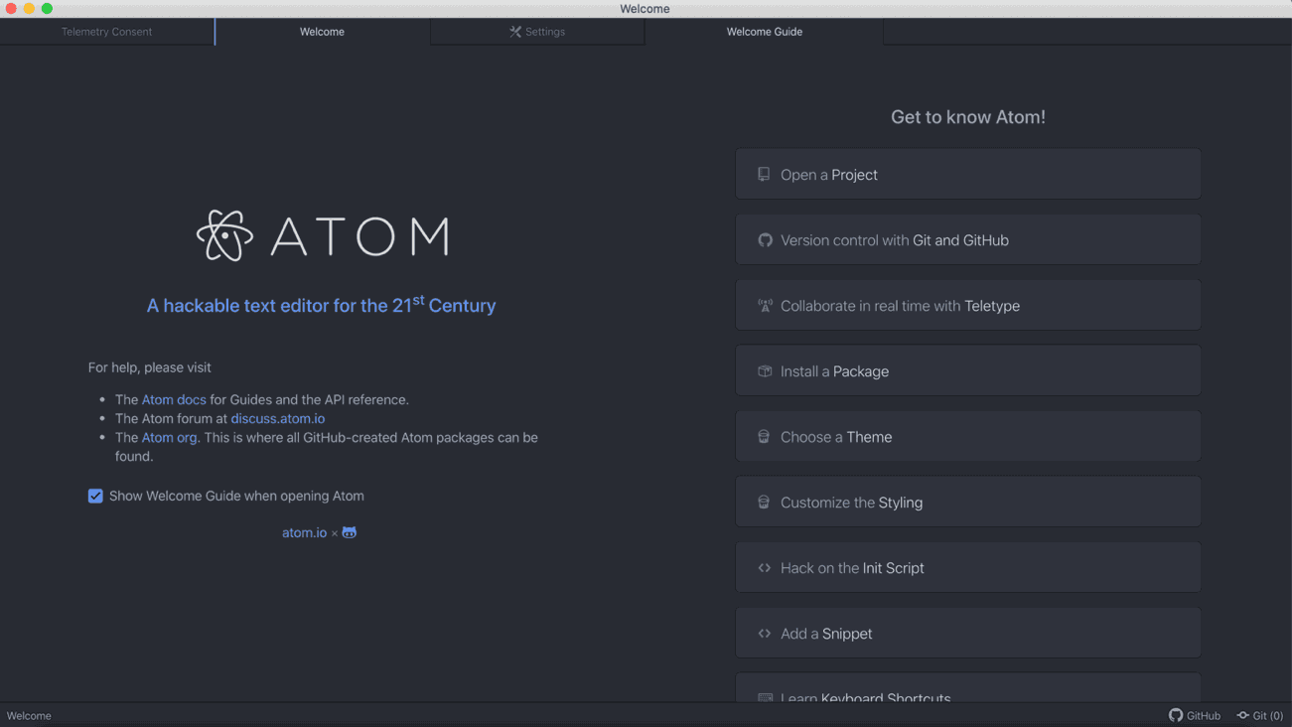

We recommend going through the welcome guide in Atom to get to know the program before starting.

‍

The first step is knowing precisely where new projects save to and where your old ones are. First, you’ll want to start your directory (aka your folder in Windows’ Explorer or Mac’s Finder). We recommend naming this something sensical and straightforward like ‘Projects.’ Every time you start a new project, create a new folder inside your project directory. If you’ve been developing for any amount of time, you know that simple projects can turn into large projects spanning many, many folders in no time.

Atom conveniently provides a tree-view of each of your projects, making it easy to see and navigate. To get there, simply select ‘File’ from the menu bar then ‘Add Project Folder.’ This will take you to your file manager. Inside your ‘projects’ folder, we recommend creating a new folder called ‘test’ and opening it in Atom. This test folder will open in the side pane of Atom. From here, you can select file > New File, and a new file will appear it Atom’s sidebar. You can then select file > Save As to name your new file. Don’t forget to select the right file extension such as .html, .css, .csv, etc.

After you’ve set up your file structure, you’re ready to start coding! Don’t forget to save often to reduce the chances of losing all your work.

**Atom Text Editor Best Practices**

One of Atom Text Editor best practices that will save you much time is file extensions and syntax highlighting. Atom offers language-specific syntax highlighting to make your code easier to read. If you look at your index.html file, you’ll notice the tags and texts show up in different colors. You can use the color scheme included with a theme you may have downloaded or create your own. If you’re using a theme, the color scheme will vary depending on which coding language you’re writing in.

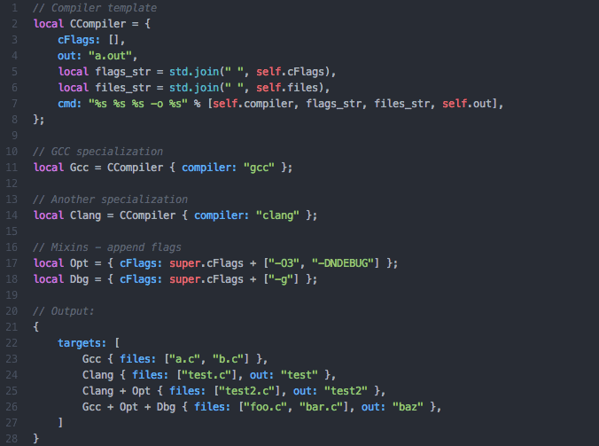

Atom offers syntax highlighting. Coding example from <https://atom.io/packages/language-jsonnet>

If you’re not happy with your current theme’s color scheme, you can simply change your theme by navigating to file>Preferences to open up the settings window. From there, select ‘themes.’ You can select one of the 4 UI themes or eight syntax themes included with Atom or download a custom one. You can also explore creating your own if none of the available options appeal to what you need in a theme.

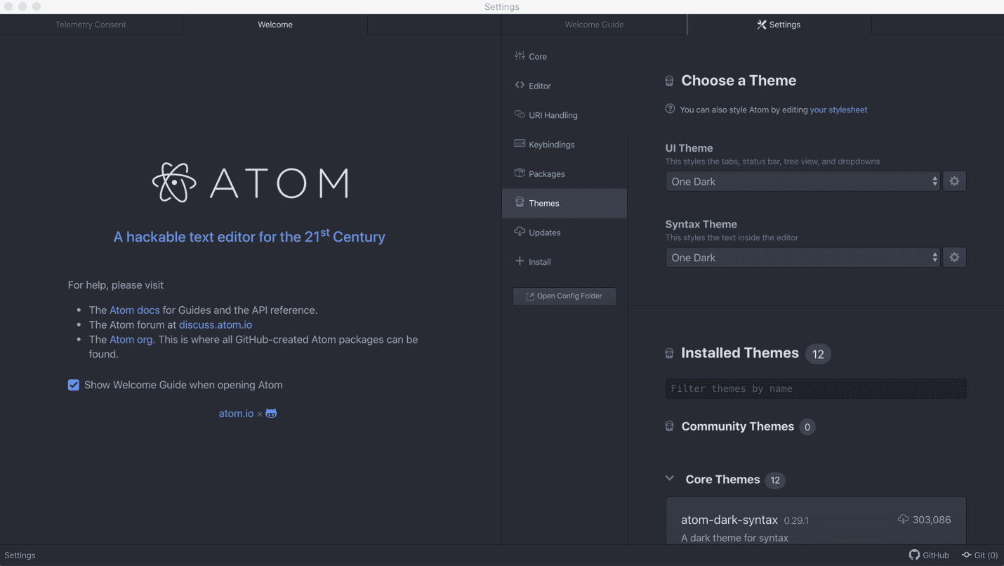

Changing the theme in Atom is made easy with the option to use a pre-designed theme or create your own.

‍

Another best practice to keep in mind is to avoid requiring too many modules straight. Instead, we recommend using lazy initialization and serialization since it can speed up your package start up.

You can also use the settings for ‘soft wrap’ and ‘soft wrap at preferred line length’ to find the line length you find easiest to use.

**Software To Increase Efficiency With Atom**

If you’re working with a development team, you know one of the most significant issues that can eat up your time is communication. Communicating what needs to be changed, improved, or fixed can take up more time than the actual task at hand.

To aid with communication while working on your development projects, we recommend downloading a free trial of CloudApp, a powerful team collaboration software that makes using visuals to communicate swifter and more straightforward than ever.

Did you know more than 1 in 2 office workers say they would collaborate more if done visually with videos, images, or video calls?

With CloudApp, you can replace the seven tools you’re using to take screenshots, screen recordings, and annotative GIFs with one simple, easy-to-use tool.

You can quickly annotate a screenshot, take a video with the [screen recorder](https://www.getcloudapp.com/screen-recorder), or make a GIF to explain in mere seconds where that bug is or how that new feature in your app works.

But don’t take my word for it! Try it out completely free and see if it works for you and your team.

**Is Atom Better than Sublime?**

What is the best text editor for developers? While there is no conclusive, one-size-fits-all answer, there are some pros and cons to both Atom and Sublime that every developer should consider. Depending on what you’re building, and which features are imperative to you, this can help you decide on which text editor may be the best fit for you.

**Sublime**

First, let’s take a look at Sublime. On the spectrum of convenience to extensibility, editors like Sublime fall closer to the convenience end. Sublime was released back in 2007 by former Google Engineer Jon Skinner. It’s had almost a decade longer to mature than Atom. Like Atom, Sublime is available on OSX, Windows, and Linux. However, Sublime comes with a $70 license fee with its free trial.

Similarly to Atom, there are a plethora of themes and packages to install. However, to get started, you’ll have to add the Sublime Package Control plugin before you install any packages. It’s a small hurdle, but many developers feel this should automatically be installed by default.

If you’re looking for a text editor that you can quickly install and get started with, Sublime might not be for you. Sublime only becomes a quick and powerful editor with the right plugins. To find out more about these plugins, we recommend checking out this blog:

The Top 10 Sublime Text Plugins For Web Developers 2020.

The usage of Atom can be subjective since it so strongly depends on which plugins you’ve installed. The upside is that if you’re particular about your text editor, you can customize it precisely how you want it. The only downside is the time it can take installing plugins and customizing.

**Atom**

Even though it’s new compared to Sublime, Atom has garnered a loyal following since its initial release in 2014. One of the first and most obvious benefits of Atom over Sublime is that it’s free. Additionally, because Git Hub created Atom, the integration between the two is seamless.

If being able to customize your file structure is important to you, Atom makes this easy with its tree view of your file structure. You can simply drag and drop your folders to keep things organized.

One feature present in Atom and not sublime that many developers love is the live preview option. In the ‘packages’ option in the top menu bar, select **atom-live-server** option. This enables you to quickly and easily view your live web application in your browser with the simple click of a button. Remember, you’ll need the **atom-live-server** package enabled to see these features.

So, is Atom better than Sublime? We’ll let you decide for yourself, but we hope this quick comparison helps you get started in making the right decision to get started with either text editor.

Information from Cloud App.

Mashup (web application hybrid)

A **mashup** (computer industry [jargon](https://en.wikipedia.org/wiki/Jargon)), in [web development](https://en.wikipedia.org/wiki/Web_development), is a [web page](https://en.wikipedia.org/wiki/Web_page) or [web application](https://en.wikipedia.org/wiki/Web_application) that uses content from more than one source to create a single new service displayed in a single graphical interface. For example, a user could combine the addresses and photographs of their library branches with a Google map to create a map mashup.[[1]](https://en.wikipedia.org/wiki/Mashup_(web_application_hybrid)#cite_note-1) The term implies easy, fast integration, frequently using open application programming interfaces ([open API](https://en.wikipedia.org/wiki/Open_API)) and data sources to produce enriched results that were not necessarily the original reason for producing the raw source data. The term mashup originally comes from creating something by combining elements from two or more sources.[[2]](https://en.wikipedia.org/wiki/Mashup_(web_application_hybrid)#cite_note-2)

The main characteristics of a mashup are combination, visualization, and aggregation. It is important to make existing data more useful, for personal and professional use. To be able to permanently access the data of other services, mashups are generally [client applications](https://en.wikipedia.org/wiki/Client_(computing)) or hosted online.

In the past years[[*when?*](https://en.wikipedia.org/wiki/Wikipedia:Manual_of_Style/Dates_and_numbers#Chronological_items)], more and more Web applications have published APIs that enable software developers to easily integrate data and functions the [SOA](https://en.wikipedia.org/wiki/Service-oriented_architecture) way, instead of building them by themselves. Mashups can be considered to have an active role in the evolution of [social software](https://en.wikipedia.org/wiki/Social_software) and [Web 2.0](https://en.wikipedia.org/wiki/Web_2.0). Mashup composition tools are usually simple enough to be used by end-users. They generally do not require programming skills and rather support visual wiring of [GUI widgets](https://en.wikipedia.org/wiki/GUI_widget), services and components together. Therefore, these tools contribute to a new vision of the [Web](https://en.wikipedia.org/wiki/World_Wide_Web), where users are able to contribution

The term "mashup" is not formally defined by any standard-setting body.[[3]](https://en.wikipedia.org/wiki/Mashup_(web_application_hybrid)#cite_note-3)

Information from Wikipedia

Webparts

Web part

From Wikipedia, the free encyclopedia

[Jump to navigation](https://en.wikipedia.org/wiki/Web_part#mw-head)[Jump to search](https://en.wikipedia.org/wiki/Web_part#searchInput).

A **Web Part**, also called a [Web Widget](https://en.wikipedia.org/wiki/Web_widget), is an [ASP.NET](https://en.wikipedia.org/wiki/ASP.NET) server control which is added to a Web Part Zone on [Web Part Pages](https://en.wikipedia.org/w/index.php?title=Web_Part_Pages&action=edit&redlink=1) by users at run time. The controls enable end users to modify the content, appearance, and behavior of Web pages directly from a browser. It can be put into certain places in a web page by end users, after development by a programmer.

Web Parts can be used as an add-on ASP.NET technology to [Windows SharePoint Services](https://en.wikipedia.org/wiki/Windows_SharePoint_Services).

Web Parts are equivalent to [Portlets](https://en.wikipedia.org/wiki/Portlet), but don't necessarily require a [web portal](https://en.wikipedia.org/wiki/Web_portal) such as [SharePoint](https://en.wikipedia.org/wiki/SharePoint) to host them.

See also[[edit](https://en.wikipedia.org/w/index.php?title=Web_part&action=edit&section=1)]

* [Portlet](https://en.wikipedia.org/wiki/Portlet)
* [Web widget](https://en.wikipedia.org/wiki/Web_widget)
* [ASP.NET](https://en.wikipedia.org/wiki/ASP.NET)
* [Windows SharePoint Services](https://en.wikipedia.org/wiki/Windows_SharePoint_Services)
* [SharePoint Portal Server](https://en.wikipedia.org/wiki/SharePoint_Portal_Server)
* [Microsoft Office SharePoint Server 2007](https://en.wikipedia.org/wiki/Microsoft_Office_SharePoint_Server_2007)
* [Microsoft SharePoint 2010](https://en.wikipedia.org/wiki/Microsoft_SharePoint_2010)

Grow with Klaviyo mailing group

Join a forum: internet archive

